**Highway 20 Day-Of Information**

The event details are listed below:

**Event Details:**

* **Date:** Tuesday, October 14th, 2025
* **Meeting Point:** [43W550 US Highway 20, Hampshire, IL 60140](https://maps.app.goo.gl/8xpX1imcRaaDjgwf9)
* **Time:** 3:00 – 4:00 p.m. CT

**Event Location**

The best address to reach the solar farm is 43W550 US Highway 20, Hampshire, IL 60140. However, this address may not show up correctly on your map. For the most accurate directions, please input the longitude/latitude of the site (42°05'19.5"N 88°27'47.7"W) into your maps, or click on the address in the event details above to get Google Maps directions to the solar farm.

**Arrival and Parking**

Please plan to arrive fifteen minutes before the event starts, so that you have enough time to park and check in. Upon arrival, you will see a Nautilus Solar flag marking the entrance to the site. I’ve included a photo for arrival and parking reference below. The access road, connected directly to Highway 20, is marked in blue, and the event parking is marked in red.

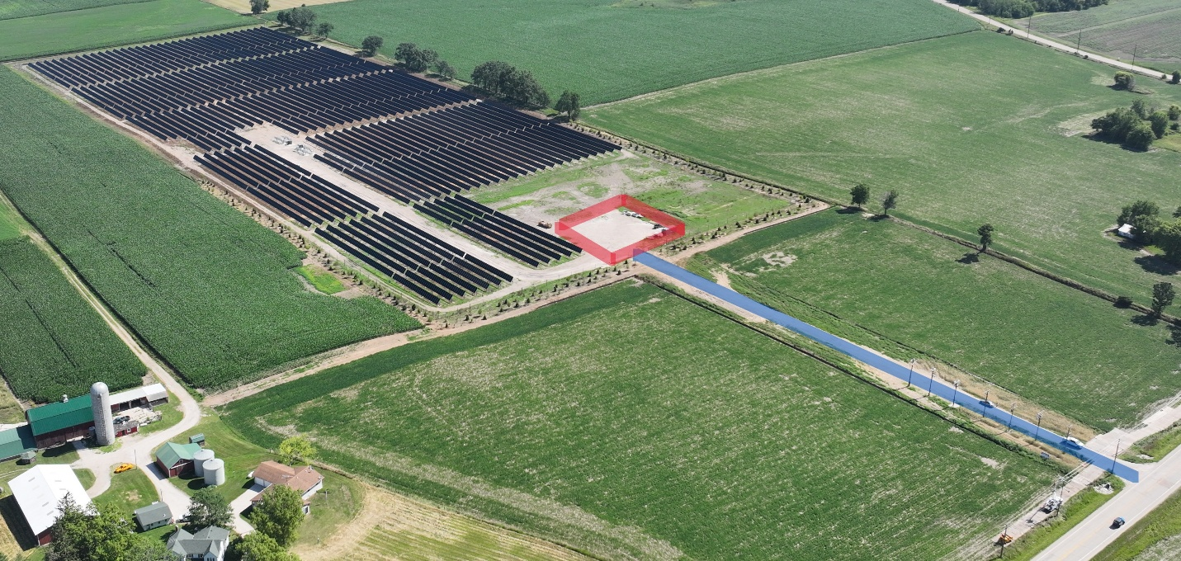

**Dress Code**

The dress code for this event is business. We will be outdoors, so please plan on wearing comfortable shoes, as we will be walking on mainly gravel and grass.